ANALYTICS DOCUMENT

BY SHUBHAM BANSLA

Index

- Data Migration from Backend to BigQuery
1.1 Introduction
1.2 Process
1.3 Documentation

- Data Migration from Urban Airship to Big Query
2.1
2.2
2.3

- Queries for analysis and Data Extraction
3.1 Introduction To Analysis
3.2 Analysis
3.3 Data Extraction
3.4 Connection with BigQuery
3.5 Weekly Product Review

- Dashboard Generation Process
4.1 Introduction To Google Data Studio
4.2 Process To Generate Dashboard
4.3 Mailing and Downloading Dashboard

- BigQuery Structure
5.1 Introduction to BigQuery
5.2 BigQuery Structure

- Recommendation Engine
6.1 Introduction To ALS algorithm
6.2 Business Problem
6.3 Model Creation
6.4 Project Content

- Data Migration from Backend to BigQuery

1.1 INTRODUCTION

Analytics team has the responsibility of tracking what is happening in the app on a daily basis like how many people are visiting coming to app, how many of them are playing etc. and to create performance metrics which helps the business to develop and grow in various aspects.
Analytics team also have the responsibility to track the performance of new feature added in the app.
For tracking and calculating the performance metrics each page of the app is tracked by some events. These events or the data comes from backend. Data which is coming from the backend is nothing but the events which are associated with each button or banner.

1.2 PROCESS

Firstly the events are created by the analytics team, name of these events are not at random, the name of the events depends on which button or page that event is present. These events is then given to the backend team.

After that Backend team will add events to the button or the banners in the app which are given by the analytics team. These events then transferred to urban airship database which comes in the tables as JASON format. From this JASON format analytics team will extract the information into table form and store in the bigquery database.

1.3 DOCUMENTATION

1.3.1 Pay2Play-Analytics :-
There are various pages in the app which have different buttons and banner which are associated with various events. Please refer the link for these events.
https://docs.google.com/document/d/1y3xQRWKRwcgNkSH2NsLqxlRLqj8Iz3ESbG5ArQB5Rgs/edit

1.3.2 Swoo Analytics Taxonomy :-
To create events on the various pages in excel is created in which gives the information about on which page a particular event is present and what is the action performed by this event. For details please refer the link below.
https://docs.google.com/spreadsheets/d/1tmnCAJphP3P790TrNhGkTDc3BEGIClaJ3vDeKlUzC5Q/edit#gid=0

2. Data Migration from Urban Airship to Big Query

2.1 INTRODUCTION

Analytics team has the responsibility of tracking what is happening in the app on a daily basis like how many people are visiting coming to app, how many of them are playing etc. and to

2.2 Jenkins
Script Names:

2.1 Daily Job

3. Queries for Analysis and Data Extraction

3.1 INTRODUCTION TO ANALYSIS

Apart from creating daily dashboard various analysis is being carried out and data is extracted which help marketing team and business to understand the behaviour of the users who are using the app and users who are not using the app.

3.1 Analysis

- User Video Watching Behaviour

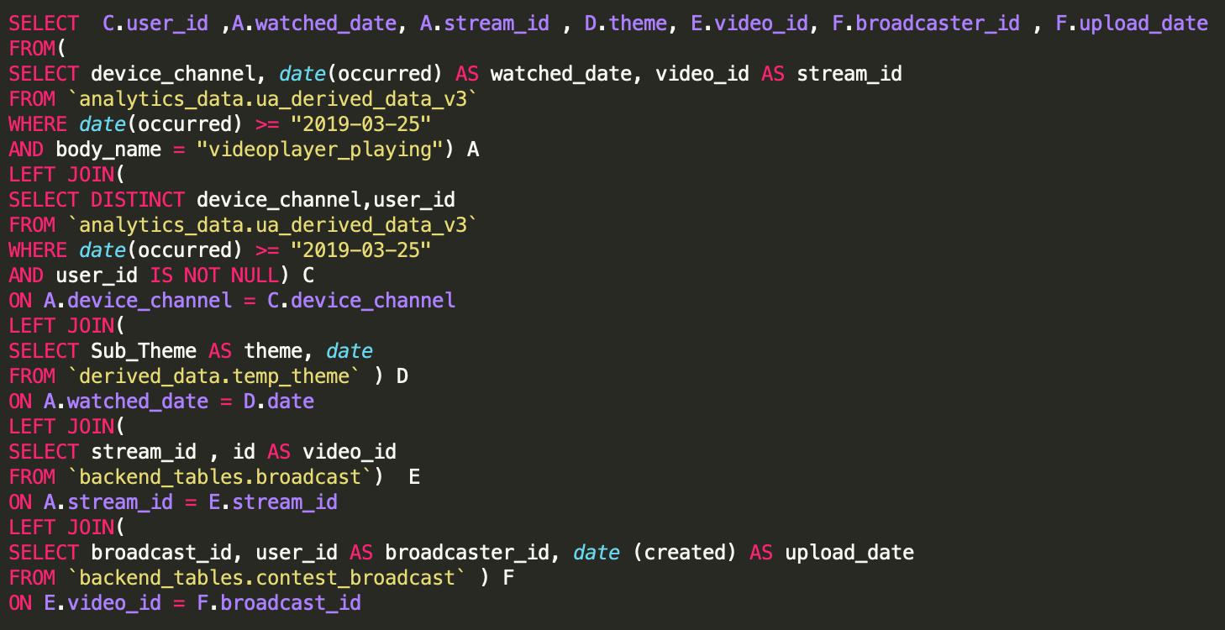
2. Contest Players Demographics

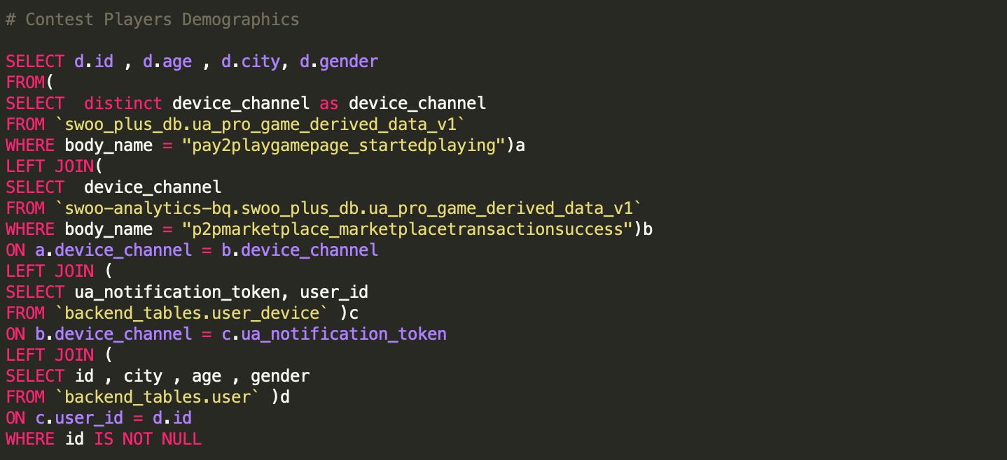

3. Gems Economy

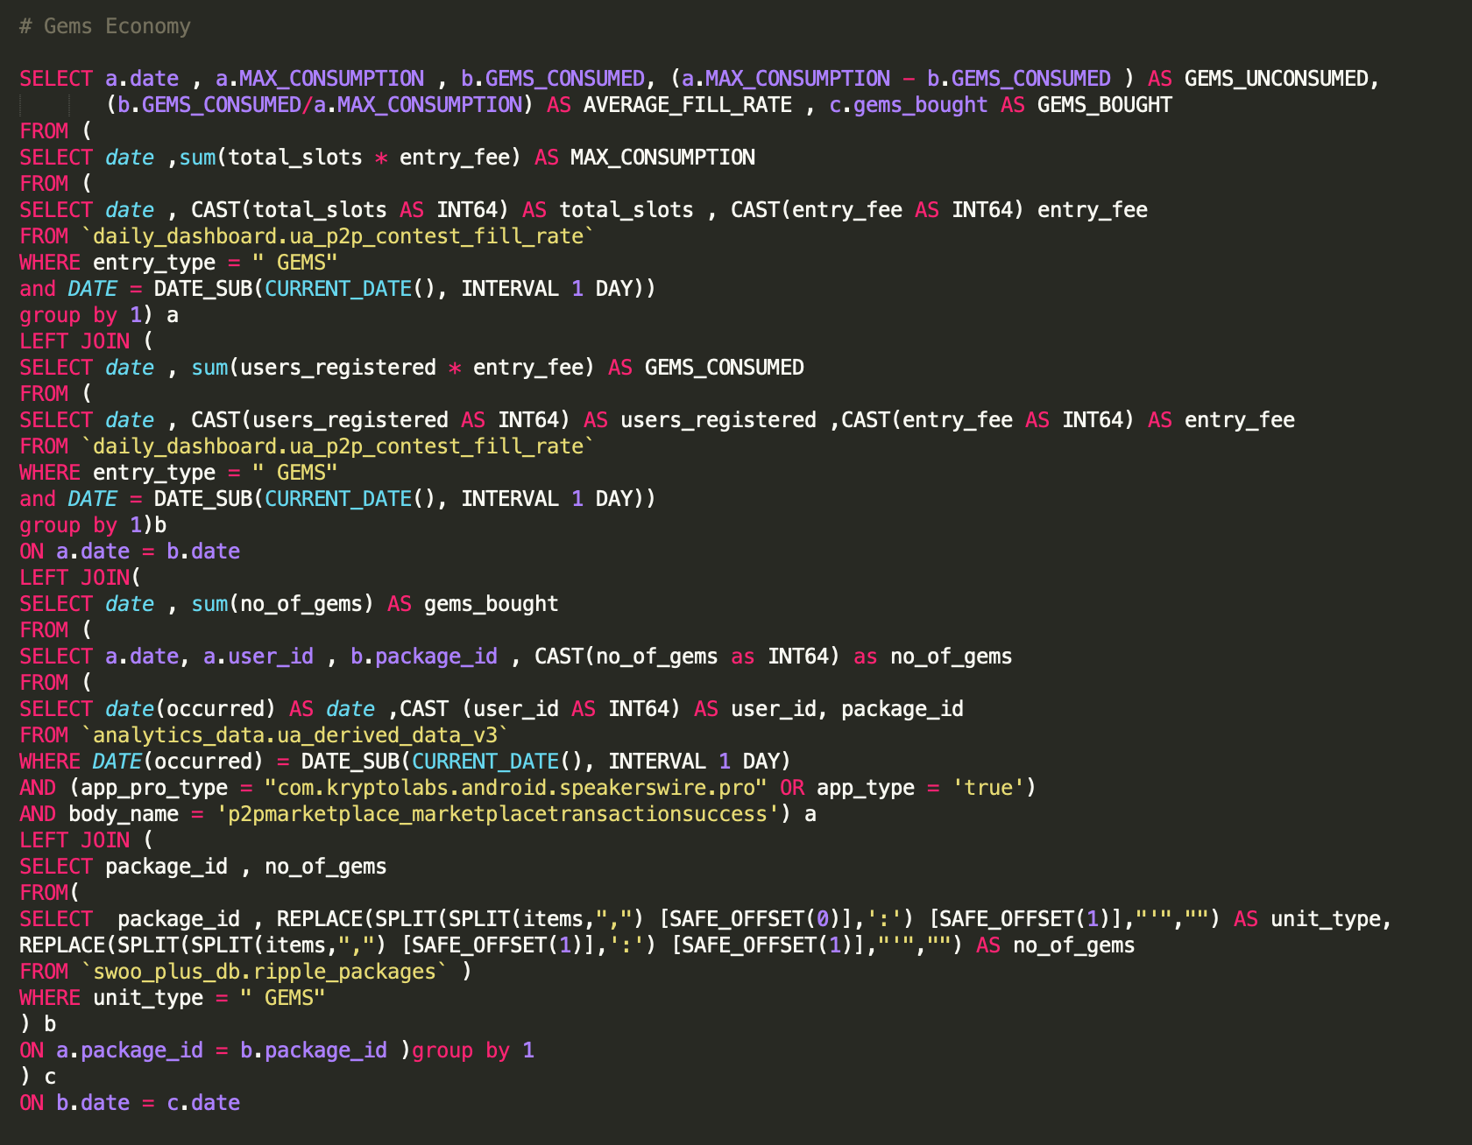
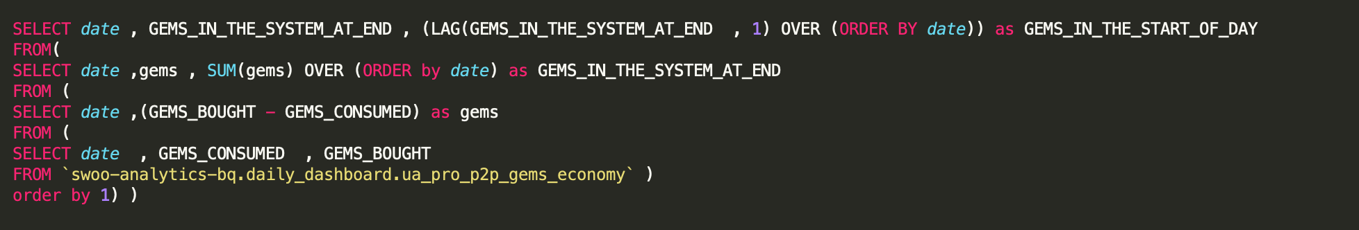

4. Analysis of Games venn diagram
Examples

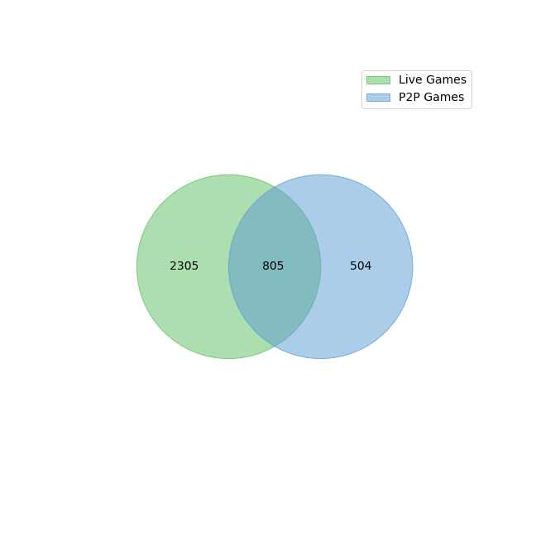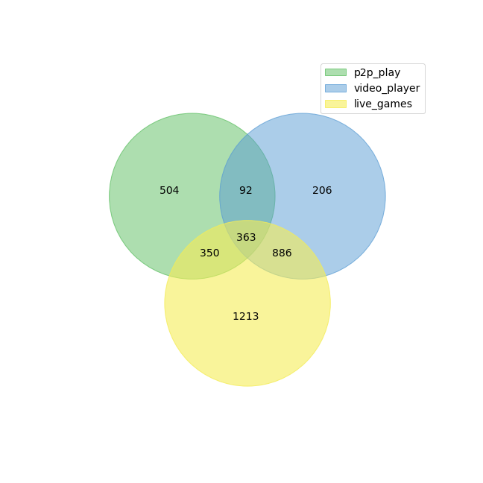
Python Code for this analysis refer the link:-
https://drive.google.com/open?id=1K-mhdoPOpbj4QvICiYmTcxipLNbEV_y3

5. Miscellaneous Analysis

- Raw Queries
https://drive.google.com/file/d/1pHNR2TcWpEZE_FZLyxnY9X-zSZscskSL/view?usp=sharing
- https://drive.google.com/open?id=19ttsY1_HDsa3YuliTaZUzpE9KX8MKUlT
- https://drive.google.com/file/d/1QzgFmQR5ukT6qp27M8-RtJhbmc-D21LL/view?usp=sharing

3.2 Data Extraction
For sending and promoting the app marketing team needs data of specific users like users who uninstalled the app, users won the competition etc, for that marketing team gives the user_id and handle to the analytics team with that details analytics team extract the data.
Python code is written to extract the, refer the link below:-
https://drive.google.com/open?id=1olKFtKVEv5RdPUJlwSWG5f8ynhNVd04j

3.3 Connection Of BigQuery With Python
Sometimes for analysis python is used , which is connected with the BigQuery.

Steps for Connecting Python with BigQuery:-

Step 1:- Import the libraries
Step 2:- Add credentials to connect with the project in BigQuery through json file.
Step 3:- Write you Query to extract the data from the BigQuery

Link for Json FIle :-
https://drive.google.com/open?id=14bvGUnoXL2t2aTgofpVGOrO_Bi71_TGU

Code for Connecting with python in BigQuery:-
https://drive.google.com/open?id=1fDzAaNuAwSBy5K5ybENlXOq_09UVQl2e
3.4 Weekly Product Review
Analytics team do a presentation on every thursday which include the comparison of performance of the current period and the performance of the compound period.
During this presentation various performance metrics are measured and discuss with the team.

Swoo App Presentation Link
https://docs.google.com/presentation/d/1IlUer3jHPLGjWxpYxT9F_M7a_yxzGzZCow8i2sA_eMk/edit?ts=5d3e963d#slide=id.p

Swoo Plus App Presentation Link
https://docs.google.com/presentation/d/1EJELzNfwIDN7lPMrVLQKpOUqBI_7keeKc2cxjYB3U0s/edit?usp=sharing

Process of updating the Presentation Weekly:-

Step 1 :- A Python Script is made which will run and extract all the previous data.
Link for python Script :
https://drive.google.com/file/d/1k_2Zf924_4G45jnDrTN_mMhE6LPqc11C/view?usp=sharing

Step 2 :- After the complete run of the script the data is automatically stored into the excel sheet.
Link for automated excel sheet :-
https://docs.google.com/spreadsheets/d/1ofa6ycC2yxnMgMwnymIZucX_wFX24rO5X5buOplLJ-I/edit?usp=sharing

Step 3 :- After the data of previous week is copied from this automated sheet to raw sheet which is connected to ppt slides. After updating the data from automated sheet to raw sheet the slide get updated automatically.
Link for raw sheet :-
https://docs.google.com/spreadsheets/d/11gO-YmNhhcXkqD9qk8-C3GFl1q2_szhaLz878bq_Apc/edit#gid=489974901&range=C2

4. Dashboard Generation Process
4.1 INTRODUCTION TO GOOGLE DATA STUDIO
Analytics team prepare various graphs like line charts, bar charts, venn diagram, funnel etc to track the performance of the App on a daily basis. For this graphs are made depending on the need and send daily to the team members so that they can understand how app is performing. Groups of all these graphs we called Dashboard.

For generating Dashboard we are using Google data studio, which is free, easy and easily accessible with bigquery.

This how visualisation of data looks like in Google Data Studio.
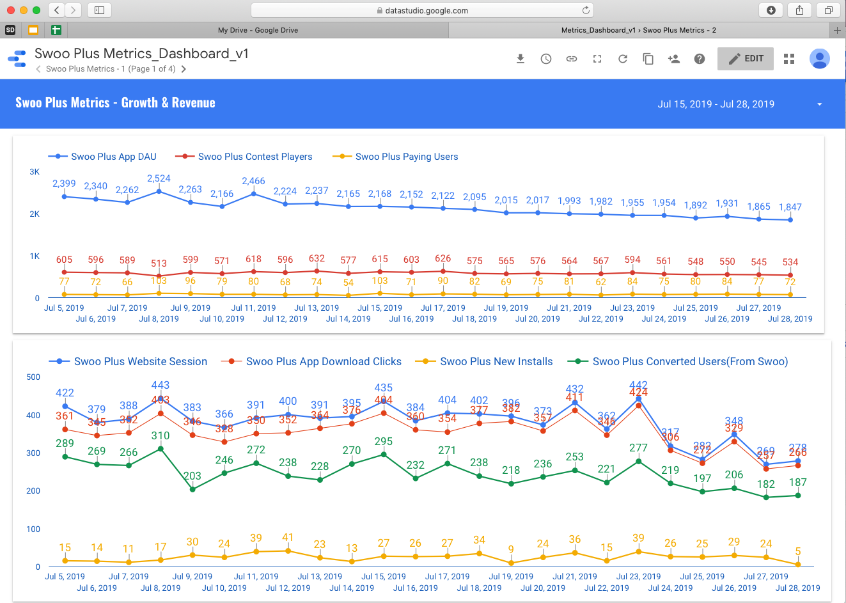
Link for all the performance metrics:
https://datastudio.google.com/open/1Iot0G7dRxKw0OrDgo2JmGt-aBoFef6VL

Link for Swoo App Daily DashBoard:
https://datastudio.google.com/open/1FBuZ3NEBY_Mq42mIuO3vqm5uWej2bNcV

Link for Swoo Plus App Daily DashBoard:
https://datastudio.google.com/open/1TEeldNYZyrzmlDYtBU6iMPH-LBaItOHg

4.2 PROCESS FLOW

All the databases in bigquery is scheduled to 10:30 AM IST till that time all the databases get updated and all the data points get reflected in the bigquery.

A script is written in python and is automated using jenkins, after the updation of all the databases this script will run and update all the tables.

Every graph is associated with a table in bigquery which is updated by the script. This Script is stored in Jenkins Item named as ETL Daily Dashboard. Inside this jenkins items two scripts are written for Swoo App and Swoo Plus App.

Swoo App Script Name :- daily_dashboard_bq.py

Swoo Plus App Script Name :- ua_p2p_daily_dashboard_v1.py

Process To Add new chart

Step 1:- Type code in terminal
- Ssh pldatascience02

Step 2 :- Give the path for the script in which you want to add
- /var/lib/jenkins/swoo-dwh/src/ETL/

Step 3 :- Give the name of the script along with the command
- Sudo vi ua_p2p_daily_dashboard_v1.py

Step 4 :- Go to the bottom of the script and insert the new code
- i

Step 5 :- After typing “i” write the query in this fashion
#### <Name of the Table>
start = time.time()
dataset_id = 'daily_dashboard'
table_ref = client.dataset(dataset_id).table('<Name of the Table>’')
job_config = bigquery.QueryJobConfig()
job_config.destination = table_ref
job_config.write_disposition = bigquery.WriteDisposition.WRITE_APPEND # In case of large memory use Append
otherwise Truncate.
sql = """
<Type your Query Here >
"""
# Start the query, passing in the extra configuration.
query_job = client.query(
sql,
# Location must match that of the dataset(s) referenced in the query
# and of the destination table.
location='US',
job_config=job_config) # API request - starts the query

query_job.result() # Waits for the query to finish
end = time.time()
time_taken = round(end-start,2)

Step 6 :- After adding the new query type command
- Press esc
- wq!

4.3 Mailing and Downloading Dashboard
After the creation of dashboard, the dashboard is downloaded and send to all the team members in pdf format.

Process of Downloading Dashboard
Step 1:- Choose the dashboard you want to download. And press the download button on the top right first icon from the left.

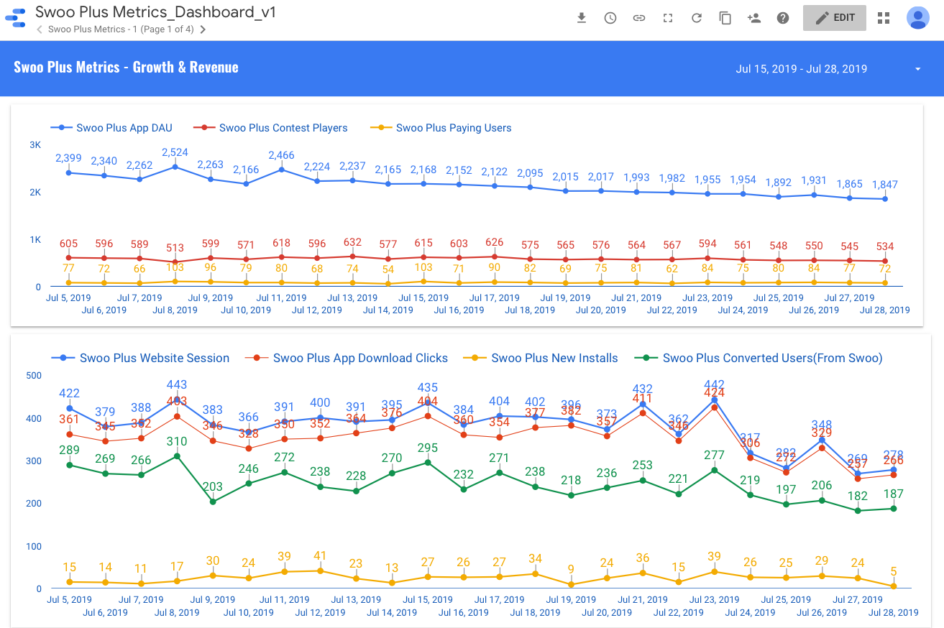
Step 2:- After clicking on the download button you will get the following option. If you want selective pages you will choose this option otherwise download. It will be downloaded as pdf.

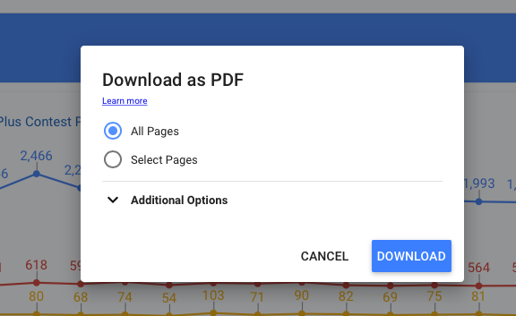

5. BigQuery Structure
5.1 INTRODUCTION TO GOOGLE BIG QUERY

Analytics team has the responsibility of tracking what is happening in the app on a daily basis like how many people are visiting coming to app, how many of them are playing etc. and to analyse various factors about the new feature added, demographics if the users etc. for all of these we are using BigQuery since it is fast and can handle huge amount of data within seconds.

How bigQuery interface looks like.

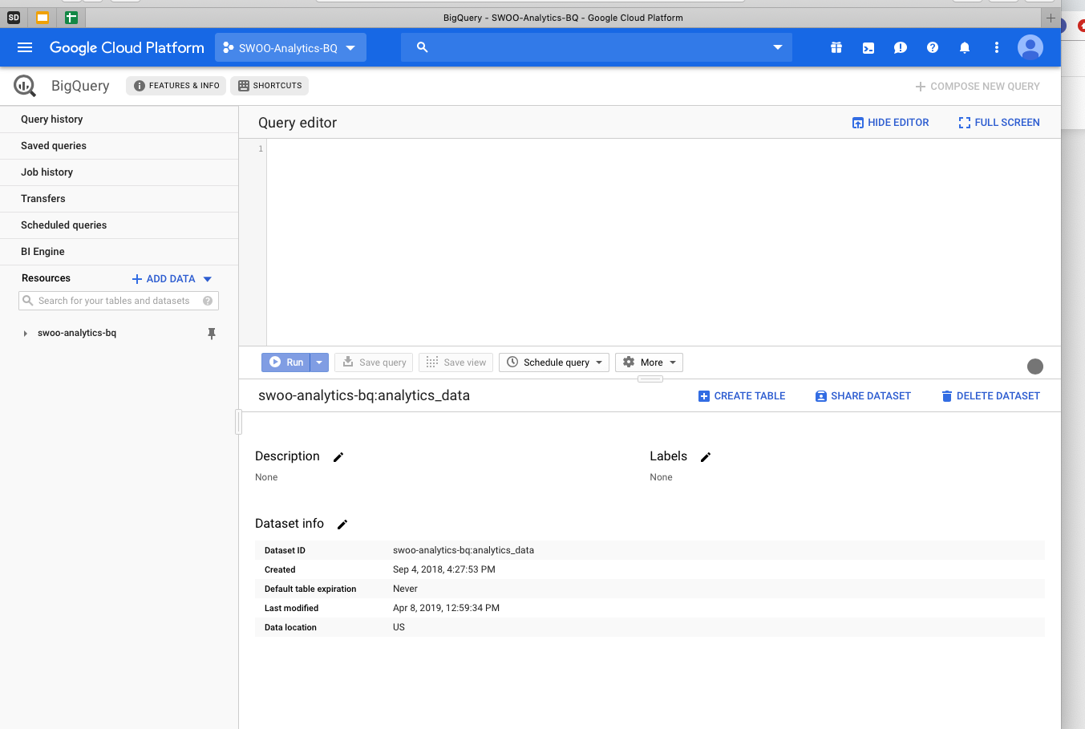

5.2 BIGQUERY STRUCTURE

Inside bigquery we are working on swoo-analytics-bq project in which various databases are present. The structure of the data bases are shown below.

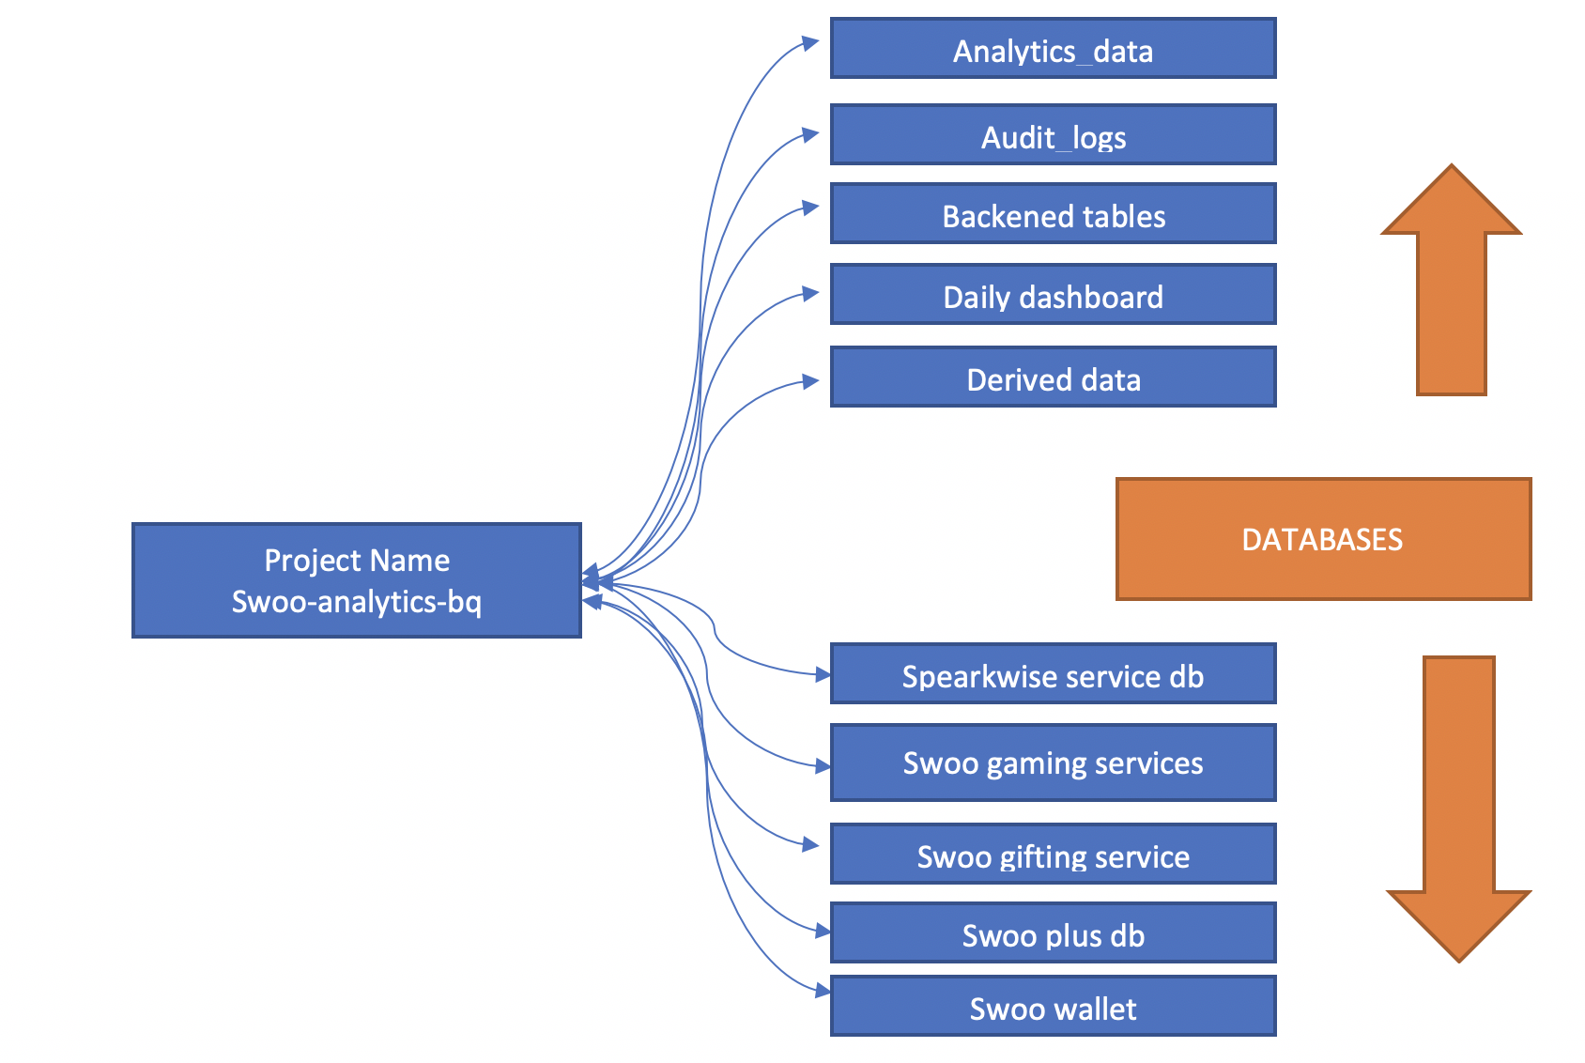

Each database contains the tables which help us to do analysis accordingly. Some important tables are specified below.

- Database - 1 :- Analytics data
urban_airship_v2
- rban_airship_raw
- urban_airship
- ua_derived_data_v3
- ua_derived_data_v1
- dates_refer

- Database - 2:- Audit Data
- Database - 3 :- Backend Tables
- User
- User_device
- User_game_statistics
- User_social_network
- Channel
- Contest_broadcast
- Boradcast
- Broadcast_video_view
- Database - 4 :- Daily Dashboard

This database is used to update the daily dashboard, for most of the charts and analysis we have to create the table so as to we can connect bigquery with the
google data studio.
- Database - 5 :- Derived Data
This database is used to make temporary tables which is only be available to 15 days only.

- Database - 6 :- Spearkwise service db
- Database - 7 :- Swoo gaming Services
All the games releated information is present in this table in the form of tables.
- Database - 8 :- Swoo Gifting Service
- Database - 9 :- Swoo Plus db
All information related to swoo plus app os present in this database
- Database - 10 :- Swoo Wallet
User wallet related information how many gems earn, spend available balance is present in this database.

6. Recommendation Engine

6.1 INTRODUCTION TO ALS ALGORITHM
It recommends based on similarity to other user. It works on the principle of
"People who agreed in the past will agree in the future, and that they will like similar kinds of items as they liked in the past."
See the picture below.
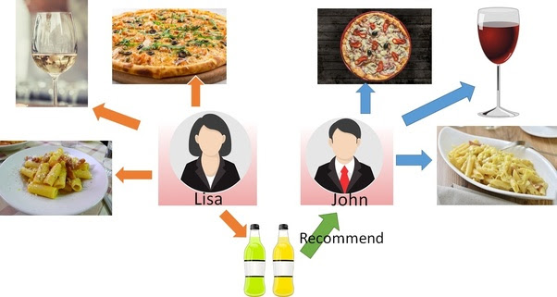

In this example, Lisa likes Pizza, Wine and Pasta. John also likes Pizza, Wine and Pasta.
So when a new product, a soft drink, is introduced and Lisa likes it, there is a higher probability that John will also like it. This is based on two similar user behavior.
+++++++++++++++++++++++++++++++++++++++++++++++++++++++++++++++++++++++++++++++++

Taking into the above consideration in our data, we have the below sample derived table :
User ID | Video ID | Ratings | Theme
111 | A | 4 | Dance
111 | B | 2 | Dance
111 | C | 3 | Dance
222 | A | 4 | Dance
222 | B | 2 | Dance
222 | C | 3 | Dance
222 | D | 5 | Holi

In this case,
- Both the Users : 111, 222 have similar taste -- Both watched Video's : A,B,C and have given similar ratings.
- User 222 has additionally watched Video - 'D' which User 111 has not watched.
- Hence, the Algorithm will recommend the Video 'D' to User 111

NOTE : In this case, though the Video 'D' belongs to different Theme but since both User's have similar pattern / likings , the Algorithm recommends Video 'D'.

Above is a sample data used for explanation. In real scenario, the Algorithm will derive many latent features which draws similarity on the patterns for different users and recommends video accordingly.

So, in our evaluation we should not be considering the below rule :
Consider the recommendation as correct only if the Theme of the Recommended Video matches with the Theme of the already watched video.

Kindly note that looking at the dataset, we have chosen the best possible algorithm. However, if the requirement is such that the "Theme" (Content based) needs to be always considered while recommending videos then we can work on different algorithms by refactoring the below Domain rules.

Re-iterating how the ratings are calculated cumulatively for each video :
- For a particular User_id , if the Video_id is both Shared and Downloaded : Score - 2 If anyone then 1, else 0
- For a particular User_id , if the Video_id is repeated more than 2 times : Score - 2, if 2 times the Score - 1, else 0
- For a particular User_id, if the Video_id belongs to a Theme which is the Top Theme then score = 1 else 0
Algorithm :
Alternating Least Squares

ALS is one of the low rank matrix approximation algorithms for collaborative filtering.
ALS decomposes user-item matrix into two low rank matrices: user and item matrix.

6.2 BUSINESS PROBLEM
Objective :
The objective of this notebook is to build a recommender system which will take input as the existing user_id and recommend 10 videos.

Tools & Technology :
Apache Spark Framework, PySpark, Jupyter Notebook

6.3 MODEL CREATION
In order to train the model on large dataset faster and make model to recommend faster the code is written in pyspark.

For code please follow the link below.
https://github.com/saaltech/saal-recommender-swoo

6.4 PROJECT CONTENT
- Load Required Libraries
- Spark Configuration
- Spark SQL and OLAP
- Spark ALS based approach for training model
- ALS Model Optimization and Hyper Parameter Evaluation
- Model Testing
- Make Video Recommendation for given User

